**Ant Colony Optimization**

**Problem:** Solve the Vehicle Routing Problem using ant colony optimization.

We have one depot and an unlimited number of vehicles of one type. As input we have:

* A list of nodes with x and y coordinates, where the node of type 0 is the depot, and the others of type 1 are customer locations.
* A list of vehicles, in this case we have one type of vehicle, which must start and end at the depot and has a certain maximum capacity of items it can transport.
* A list of requirements (what needs to be delivered to which node).

**Goal:** Find a set of delivery routes such that all packages are delivered to their owners and total costs are minimized, i.e., the smallest number of vehicles is used and the routes are as short as possible.

**Problem Solution**

The ant colony optimization algorithm was used to solve this problem. This algorithm is inspired by the behavior of ants in finding the shortest path to food. The main idea is that individual vehicles are represented by ants that go through various routes and leave pheromones that influence the decisions of other ants.

Each vehicle (ant) departs from the depot and for each place from the list of requirements, it calculates the probability of heading to this place, based on distance and pheromone trails. These probabilities are used to select the next direction. Upon reaching this direction, the vehicle repeats the described actions and also checks whether it has sufficient capacity for another order. If not, the vehicle returns to the depot and another vehicle (ant) leaves.

Each solution is then evaluated based on the distance covered by all vehicles, and based on this information, the pheromone matrix is updated. The algorithm repeats **num_iterations** times.

During the experiments, the following parameters were tuned and tested:

* Number of iterations  
    
  The result improves up to 800 iterations, after which no further improvement occurs.
* Number of ants (vehicles)  
    
  The number of 10 ants proved to be optimal, attempts to increase the number of ants to 20 or 30 did not bring any improvement in the result.
* Weighting factors for transition probability calculation  
    
  Parameters **alpha**, **beta**, and **rho** have a significant impact on the outcome. Regarding the first two, a ratio of **beta** = **3 alpha** proved to be optimal. For the speed of pheromone evaporation, values of 0.4 and 0.8 had a negative effect on the result compared to the value of 0.6, which was retained.

**Results**

* data_32.xml  
    
  Distance: 851.8769552374947

Number of vehicles: 5

Running time: 9s

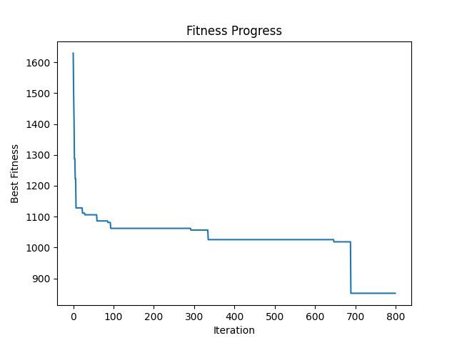  
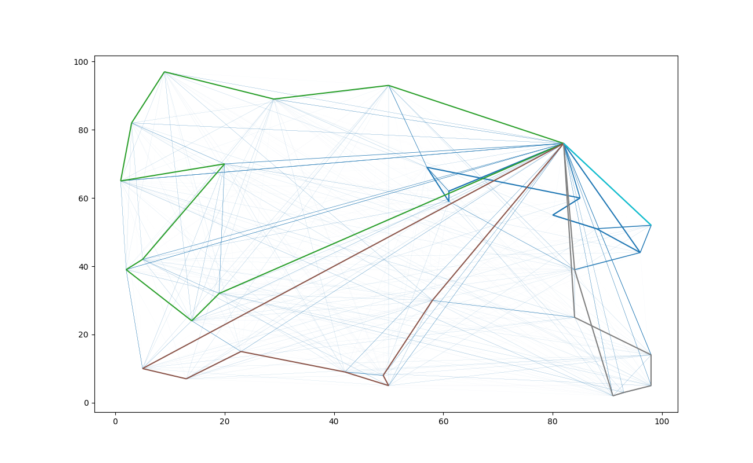

* data_72.xml  
    
  Distance: 310.88976886481936

Number of vehicles: 4

Running time: 27s

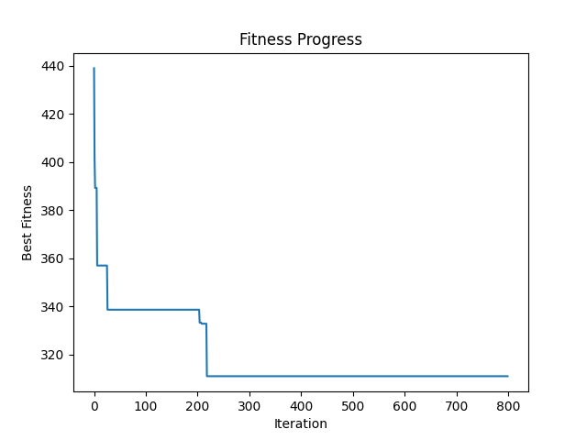

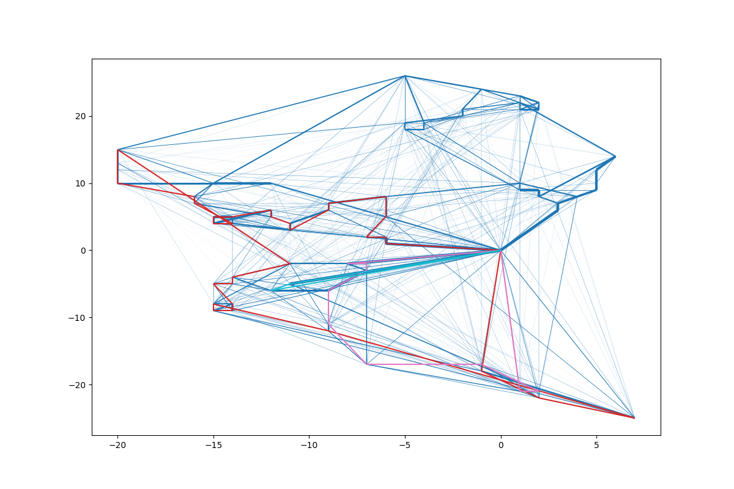

* data_422.xml

Distance: 2978.346657491171

Number of vehicles: 38

Running time: 11m 1s

